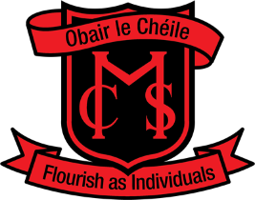
Monaghan Collegiate School
Parents’ Association
Sale of Work
We are delighted that our annual Sale of Work will be taking place this year
on Friday, December 2nd in St. Patrick’s Hall. As always, the success of this
fundraiser is heavily dependent on the support of all our parents, and
we encourage you to be as generous as possible with your time and gifts.

The following home baking items are needed for sale at the Cake Stall and also for the tea & coffee service. Please send your items packaged for resale – we will price them on the morning of the sale. Please tick the items you can provide.
Traybakes |  |  | Cakes
Scones (uncut) |  |  | Pies
Biscuits/Cookies |  |  | Breads
Shortbread |  |  | Jams
Mince Pies |  |  | Farm Produce
Other:

Additionally, we require helpers to serve tea/coffee throughout the day.
Please tick those times you are available to help.

9:30 – 11:00 11:00 – 12:30 12:30 – 2:00

Name of Helper: ___________________Contact Number: _____________________
Alternatively,
- I would like to supply a raffle prize: ________________________

- I would like to make a donation (this can be done through Easy Payments on the school website or handed in to the school office) € ______

Childs name: __________________________ Class _______
St. Patrick’s Hall will be open on Thursday evening from 7:00-8:00pm to allow us set up the tables and to give parents the opportunity to drop off their baking & produce.
Please return the form to the School office by Friday 25th November 2022.
Thank you for your support!

